Candy’s fantastic expedition

Character

Candy is the heroine of game. She is a college girl with great curiosity and courage. One day she falls into a miraculous dreamland.



Candy

Figure1. Character Introduction

* Candy could also act as a role to introduce waste management information in non-game section.

The game start with by a map. Candy should pass 4 scenes so as to finish her adventure. The 4 scenes are:

* Magical Land
* Candy’s Trouble
* Resort It!
* Return to Innocence

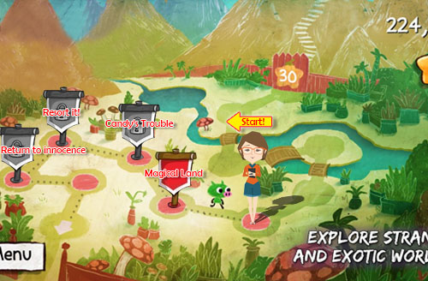

Figure2. The Main page of game

First scene：Magical Land

*Nature produces resources. While we consume them to get energy and generate waste.*

**Story line:**

Candy is just a little girl at this time. She is hungry, and needs food to eat and other resources to acquire energy. Driven by curiosity courage, she starts this adventure to obtain them. At first, she comes into a place called magic land. At there, any things she needs, such as Coca Cola, banana and chocolate, can grow from fields directly. It’s amazing! Candy feels so happy! Then she picks those products up from the land crazily, eating and using.

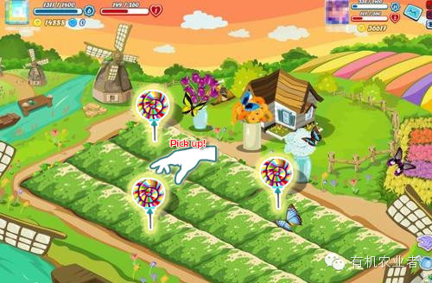

Figure3. The Main page of 1st game

**Game introduce:**

1. The products will emerge in each field randomly, and disappear in a very short time.
2. Player should click those products so soon as possible to get scores (That is all could be considered as energy in this game). When an item is clicked, product icon will be changed into corresponding waste icon.
3. The appearing time of product would be shorter and shorter when the level of this game rises.
4. When the total time is used up, the game is over.
5. If a player gets required score, he can get into next scene.

Second scene：Candy’s Trouble

*By consuming resource, human attain powerful energy. While, at the same time, the problem of great amount of waste nags us.*

**Story line:**

Candy gets enough energy. Surprisingly, she receives a gift. It’s a wings! Candy could fly now! She is so happy, and try to fly. However, there are plenty of hindrances raise up form land. They are rubbish dumps. Candy need to be very careful and fly over them quickly. It so dangerous!



Figure4. Gif of wings

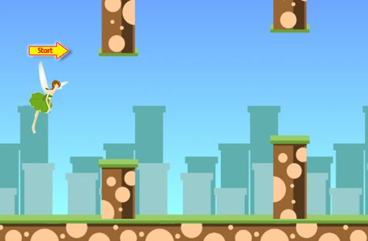

Figure5. The Main page of 2ed game

**Game introduce:**

Gift: wings.

1. Player need to click on the screen to keep the height candy flies.
2. There are obstacles raise up from ground. Candy could not collide with them.
3. Candy should fly to the end of the way. Then the player could go to next scene.

Third scene：Resort It!

*Awareness of waste resource recycling arises.*

**Story line:**

Candy landings safely. She gets 4 partners! So she could resort those waste! She needs to resort different kind of waste correctly as soon as possible!

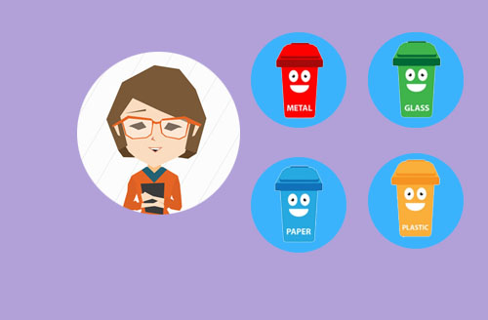

Figure5. Gifs of 4 rubbish bins

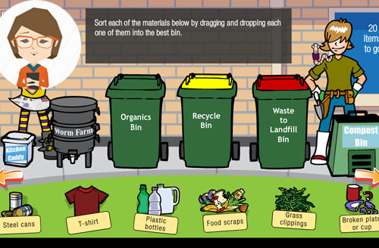

Figure6. The Main page of 3rd game

**Game introduce:**

Gift: 4 rubbish bins.

1. There are different types of waste recycle bins on the top of screen.
2. There are different types of waste randomly in the sequence on the bottom. The left one is active and others are locked.
3. Player should drag the active waste into correct garbage bin. Then he can get score and at the same time get this recycled waste (This waste would be used in next game).
4. When an active waste is dragged into waste bin correctly, the next waste move to active position, others move ahead. A new wast is supplement in the last position.
5. If a student gets required score, then he can get into next game.

*Every resorted waste will be used in next game! So in fact, this game would be played many and many times.

Last scene：Return to Innocence

*The waste finally returns to nature again. New resource will grow up again.*

**Story line:**

Candy works very hard, and, finally, resort all waste. She experiences a lot and thinks a lot. A magical thing happens again! She got a fantastic box! What will this magic box do? Candy just put the collected waste into it. Miracle suddenly happens! A seed is generated. Candy put the seed into Magical Land. After a short while, the seed sprouts, grows, and then fruit a treasure!



Figure7. Gif of magic box

**Game introduce:**

Gift: Magic box!

1. Students must use the waste recycled form last game, and then make different combination to generate seeds.
2. If there are not enough recycled waste, student could **replay 3ed scene** to get required waste.
3. Some seeds are hard to obtain, sometimes, it need students to exchange waste between each other. Payers could use Facebook or other ways to ask friends for specific waste. So it is more active than only virtual games.
4. Play need to go to 1st scene to sow seed.
5. The seeds will grow up to different treasure.
6. If a student could collect all treasures (maybe 10), then he or her could get a real prize form university, like recycle bag or a cup.

3 Plastic bottles

1Can

The recycle waste collected form last game

Different waste group generates different seed. Then put these seeds in to magic land, it will grow into different treasure

If one can collect all treasures, he could get a real prize, such as a cup, from our university

Treasure1

Treasure2

Treasure3

Treasure4

Figure8. Generate seeds

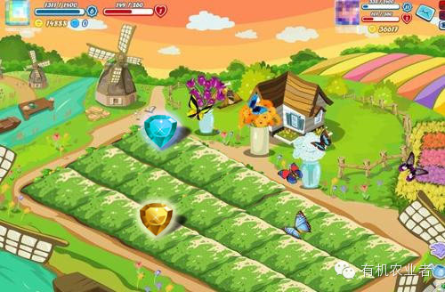

Figure8. Get treasure

Conclusion

Players need to **replay 3rd scene a lot of times**, if he wants to collect enough resorted waste to generate seeds. At this time, players could **share waste** he collected with his friends by Facebook so that to generate more magic seeds. Different seeds grow up to different treasure, if one player could gather all different, he could get a **real gift**, like a cup or T-shirt from University.

*Resources come from nature, then be consumed, discarded, resorted, finally be seeded and get regenerated. It is just like Candy, from birth, then experience magic life, and finally return to innocence.*